**RELATIONAL SCHEMA :**

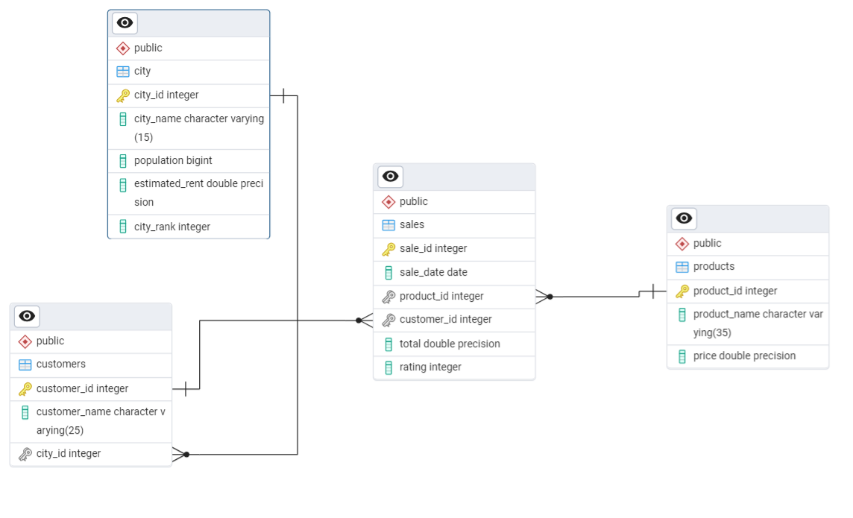

**FUNCTIONAL DEPENDENCIES :**

**TABLE :-** City

FD {city_id -> city_name, population, estimated_rent, city_rank}

Normal form :- BCNF

**TABLE :-** Customers

FD { customer_id -> customer_name, city_id}

Normal form :- BCNF

**TABLE :-** Products

FD { product_id -> product_name, price}

Normal form :- BCNF

**TABLE :-** Sales

FD { sale_id -> sale_date, product_id, customer_id, total, rating}

Normal form :- BCNF